Froggy Operating System

User’s Manual

Version 1.0

Created by: Sophia David, Makayla Davis, Andrew Hay, Kerrigan Ranshaw

September 2023

# **Table of Contents**

**Table of Contents 2**

**Introduction: 3**

**Commands: 4**

Help: 4

Version: 4

Get Date: 5

Set Date: 6

Get Time: 7

Set Time: 8

Quit: 9

Back (Date & Time menu): 9

# **Introduction:**

FroggyOS is an operating system that works by the user selecting options from a menu. The first implementation of this system allows for limited functionality. There are currently seven commands that the operating system can handle: Help, Version, Get Date, Set Date, Get Time, Set Time, and Quit. Upon booting up the machine, the terminal will present the user with a menu of commands that they are able to run. *Figure 1* shows the menu upon firing up the system.

To call a command the user must simply type the number associated with the command and press the enter key. This will then call the command and perform the actions associated with it.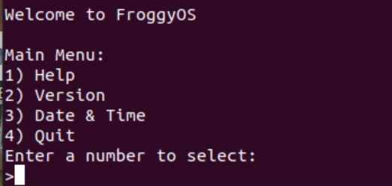

# **Commands:**

## Help:

This command shows the user a list of all of the functions and a brief description of what they do. To call the Help command, the user must first start up the Operating System. Upon the booting of the machine, the user will be prompted with a list of commands. The help function can be called by the user by typing the number 1 in the terminal and pressing enter. *Figure 2* shows the output when the help command is called. 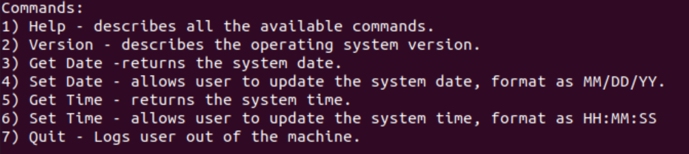

## Version:

The version is the particular form of the OS that differs in certain respects from other and/or earlier forms of the OS. As this is the first implementation of the FroggyOS, there are no earlier/other versions. The current implementation is Version 1.0. The user can obtain this information by selecting the Version command in the user menu. To call this command the user must select the second option in the menu: type the number 2 and press the enter key. This will then output a line that says “Version 1.0”. *Figure 3* shows the process of calling the Version command.

Upon later releases and updates, there will be more versions of FroggyOS.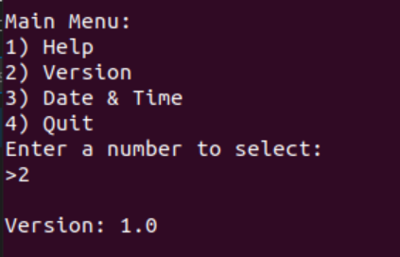

## 

## Get Date:

For the user to see the current date of the system, they can use the ‘get date’ command. This command will output the date in a 6-digit format (MM/DD/YY). First the user must select the date and time option from the menu by typing in the corresponding number and pressing enter. This will then present the user with a new date and time menu. Get date will be the first option on the list and can be selected by inputting the number associated with it. *Figure 4* shows an example of this process.

Once the get date command is selected, the date that is saved in the system will be output.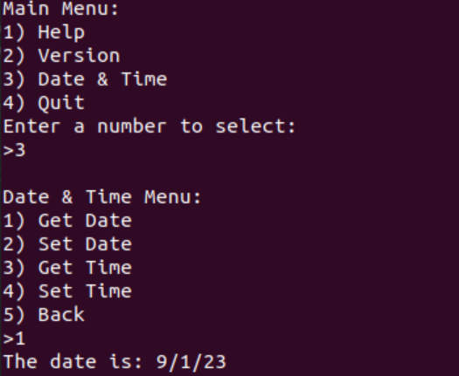

## 

## Set Date:

The set date command can be accessed through the date and time selection on the main menu. Once date and time is selected from the main menu, the user can then select the set date command, this is the second option in the date and time menu. The user will then be prompted to input the month, day, and year that they wish to set the date to. *Figure 5* can show this process in use.

The get date command can then be used to see the updated date. *Figure 6* shows the date after the set date command is called. 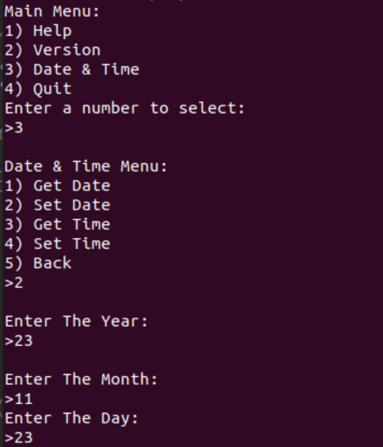

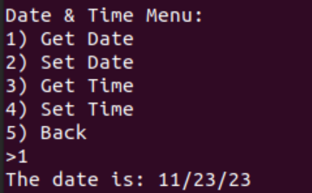

## 

## Get Time:

The get time command works similarly to the get date command. The user must select the date and time option from the main menu inorder to navigate to the date and time menu. The get time command is the third option on the menu, and can be called by inputting the corresponding number. Once the number 3 is typed and enter is pressed, the machine will output the current time it is holding in its registers. The time being held is set to UTC or coordinated universal time. *Figure 7* shows the process of calling the get time command.

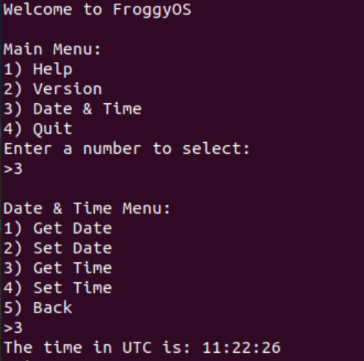

## 

## Set Time:

Just as get date and get time work similarly, set time works the same as set date. First the user must navigate from the main menu to the date and time menu, by selecting option 3. Once the date and time menu is showing, the user can then select option 4 on the list, or set time. Upon calling the command, the user will be prompted to input the seconds, the minutes, and the hours in which they wish to set the time to. This is done by typing the desired number(s) then pressing enter. *Figure 8* shows the process of setting the time.

To ensure that the time was updated correctly, the user can then run the get time command and see that the result is what they set it to. *Figure 9* shows this process, and the reason that the seconds has changed is because it takes a few seconds to call the get time command after the time has been set.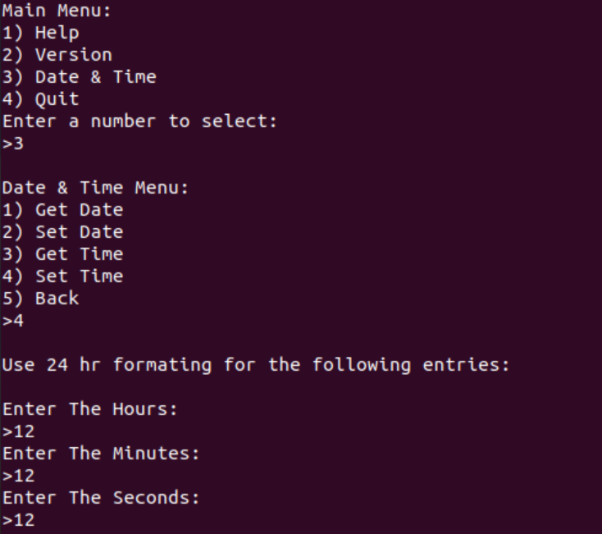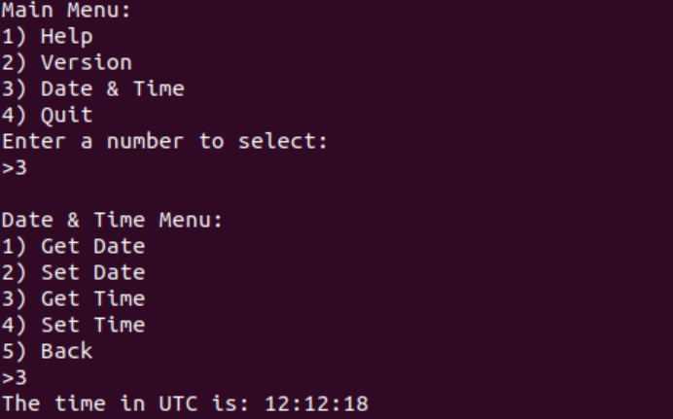

## Quit:

To close the system, the quit command will do so. To execute the command, first the user must select option 4 by typing the number in and pressing enter. Then the user will be prompted again to confirm that they would like to close the process. To confirm the shutdown, the user must type 1 then press enter, to cancel the shutdown the user can type any key then press enter or just simply press enter. *Figure 10* shows the process of shutting down the system.

## Back (Date & Time menu):

If the user selects the third option of the main menu, which takes them to the date and time menu they can select the back option, or option 5, to navigate back to the main menu. This allows the user to seamlessly switch between menu options. *Figure 11* shows the back command in use.